Architecture Diagram
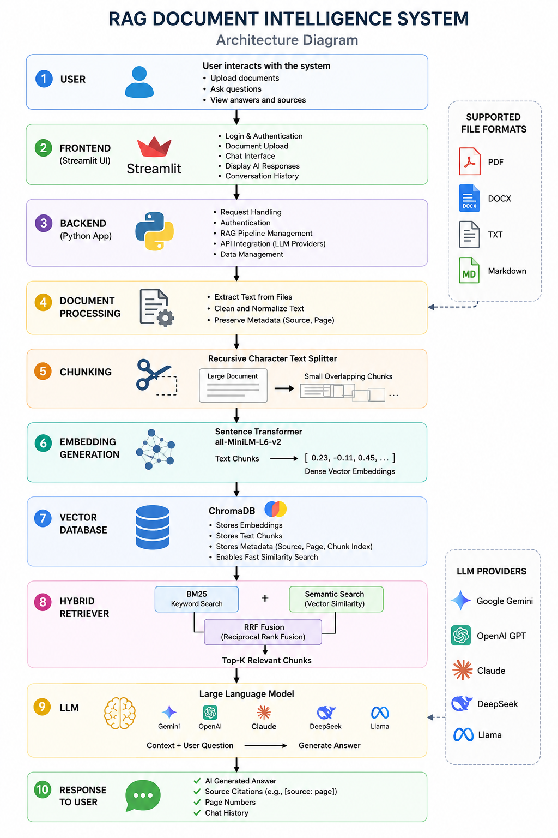
1. User
The User is the person interacting with the system. The user uploads one or more documents and asks questions in natural language. The user can also view AI-generated answers, summaries, and source citations.
Responsibilities
- Upload documents
- Ask questions
- View responses
- Review cited sources
2. Frontend (Streamlit UI)
The Frontend is built using Streamlit, providing a user-friendly graphical interface. It allows users to interact with the application without requiring programming knowledge.
Main Functions
- User Login & Authentication
- Document Upload
- Chat Interface
- Display AI Responses
- Conversation History
Input
- User documents
- User questions
Output
- Sends requests to the backend
- Displays AI-generated answers
3. Backend (Python Application)
The Backend is the core processing layer that controls the application's workflow. It connects all modules together and manages communication between the frontend, database, retriever, and AI model.
Main Functions
- Handle user requests
- Authenticate users
- Manage the RAG pipeline
- Connect with LLM providers
- Manage document storage
Why it is important
The backend acts as the brain of the application, ensuring every request follows the correct processing pipeline.
4. Document Processing
After a document is uploaded, it is processed before it can be searched.
Supported File Types
- PDF
- DOCX
- TXT
- Markdown (.md)
Main Tasks
- Extract text from files
- Remove unnecessary spaces and formatting
- Preserve metadata such as document name and page number
Output
A clean text version of the uploaded document.
5. Chunking
Large documents are divided into smaller pieces called chunks.
Instead of sending an entire document to the AI model, the document is split into overlapping sections using a Recursive Character Text Splitter.
Why Chunking?
- Improves retrieval accuracy
- Maintains context between chunks
- Reduces memory usage
- Fits within the LLM's token limit
Output
Multiple overlapping text chunks ready for embedding.
6. Embedding Generation
Each chunk is converted into a numerical vector called an embedding.
The project uses the Sentence Transformer all-MiniLM-L6-v2 model.
Purpose
Embeddings capture the semantic meaning of text, allowing the system to retrieve relevant information even if different words are used.
Example
Text Chunk
"Machine learning is a subset of Artificial Intelligence."
Embedding
[0.23, -0.11, 0.45, 0.78, ...]
Output
Dense vector representations of every text chunk.
7. Vector Database (ChromaDB)
The generated embeddings are stored in ChromaDB, which serves as the vector database.
Stored Information
- Text chunks
- Vector embeddings
- Source document
- Page numbers
- Chunk index
Purpose
Provides fast similarity search over document embeddings.
Instead of searching using keywords alone, ChromaDB searches based on semantic similarity.
8. Hybrid Retriever
The retriever identifies the most relevant document chunks for the user's question.
This project uses Hybrid Retrieval, combining two search techniques.
BM25 Search
- Keyword-based search
- Finds exact words and phrases
- Good for IDs, names, and technical terms
Semantic Search
- Vector similarity search
- Finds similar meanings
- Understands paraphrased questions
Reciprocal Rank Fusion (RRF)
The results from BM25 and Semantic Search are merged using Reciprocal Rank Fusion (RRF).
This produces a more accurate ranking than using either search method alone.
Output
Top-K most relevant document chunks.
9. Large Language Model (LLM)
The retrieved document chunks are passed to a Large Language Model.
Your system supports multiple AI models, including:
- Google Gemini
- OpenAI GPT
- Claude
- DeepSeek
- Llama
Input
- User question
- Retrieved document chunks
Processing
The LLM reads only the retrieved context and generates an answer based on that information. This Retrieval-Augmented Generation (RAG) approach reduces hallucinations and improves factual accuracy.
Output
A context-aware answer with source citations.
10. Response to User
The final answer is displayed through the Streamlit interface.
The response contains:
- AI-generated answer
- Source citations
- Page numbers
- Conversation history
- Accurate responses based on uploaded documents
This enables users to verify where the information came from and trust the generated output.

